Lei Liu

LL28379

Jacob Perlmutter

JAP4843

September 15, 2016

**Lab 3 Report**

**A) Requirements Document**

1. **Overview**
   1. **Objectives**: The objectives of this project are to design, build and test an alarm clock. Educationally, students are learning how to design and test modular software and how to perform switch/keypad input in the background. Learning how to design circuits on PCB artist is another objective of this lab. **Another objective is to understand interfacing with a transistor and diode on a breadboard while transmitting switch input data to the microcontroller and processing the data. Other objectives include using systick timer, in depth use of displaying data onto the LCD, and outputting sound from microcontroller.**
   2. **Process:** The project will be developed using the TM4C123 board. The system will be built on a solderless breadboard and run from the usual USB power from a pc. The system will use the onboard switches and a few external switches. The speaker will be external to the microcontroller. There will be at least four hardware/software modules: switch/keypad input, time management, LCD graphics, and sound output. The process will be to design and test each module independently from the other modules. After each module is tested, the system will be built and tested.
   3. **Roles and Responsibilities:** EE445L groups will be the engineers and the TA is the client. Each student is required to understand what the project is and how to design it. **Lei and Jacob will both program the files needed for the project but Lei will focus on switch and speaker files while Jacob will focus on LCD and timer files. Lei will also focus more on the report while Jacob focuses on the hardware. Both members will work on all tasks, but each will have specific tasks to finish.**
   4. **Interactions with Existing Systems**: The system will use the TM4C123 board, a ST7735 color LCD, a solderless breadboard, and be powered using the USB cable. **Other externals to be used for this project will be switches, transistor, diode and a speaker.**
   5. **Terminology**: **Power budget is the amount of power available to be used**. **Device driver is the collection of software routines that perform I/O functions. Critical section occurs when multiple functions try to modify a specific memory at the same time. Latency is the response time of computer to external events. Time jitter is the delay that occurs when multiple interrupts are running. Modular programming is a style of developing software by dividing software problems into more distinct and independent modules.**
   6. **Security**: The system may include software from Tivaware and from the book. No software written for this project may be transmitted, viewed, or communicated with any other EE445L student past, present, or future (other than the lab partner of course). It is the responsibility of the team to keep its EE445L lab solutions secure.
2. **Function** **Description**
   1. **Functionality**: The clock must be able to perform five functions. 1) It will display hours and minutes in both graphical and numeric forms on the LCD. The graphical output will include the 12 numbers around a circle, the hour hand, and the minute hand. The numerical output will be easy to read. 2) It will allow the operator to set the current time using switches or a keypad. 3) It will allow the operator to set the alarm time including enabling/disabling alarms. 4) It will make a sound at the alarm time. 5) It will allow the operator to stop the sound. An LED heartbeat will show when the system is running. **The clock built will also have a snooze function that will set the alarm to go off again in five minutes. The clock will be able to be set with two buttons, one that decrements and one that increments time.**
   2. **Scope**: Phase 1 is the preparation; phase 2 is the demonstration; and phase 3 is the lab report.
   3. **Prototypes**: A prototype system running on the TM4C123 board, ST7735 color LCD, and solderless breadboard will be demonstrated. Progress will be judged by the preparation, demonstration and lab report.
   4. **Performance**: The system will be judged by three qualitative measures. First, the software modules must be easy to understand and well-organized. Second, the clock display should be beautiful and effective in telling time. Third, the operation of setting the time and alarm should be simple and intuitive. The system should not have critical sections. All shared global variables must be identified with documentation that a critical section does not exist. Backward jumps in the ISR should be avoided if possible. The interrupt service routine used to maintain time must complete in as short a time as possible. This means all LCD I/O occurs in the main program. The average current on the +5Vpower will be measured with and without the alarm sounding.
   5. **Usability**: There will be **four** switch inputs. In the main menu, the switches can be used to activate 1) **set time** 2) **set alarm** 3) **increment time/turn alarm off** and 4) **decrement time/snooze alarm**. **The user will be able to snooze alarms, scroll through settings with the settings button input and set time and alarm**. **There will also be a heartbeat that goes off each second that passes.** The user should be about to control some aspects of the display configuring the look and feel of the device. The switches MUST be debounced, so only one action occurs when the operator touches a switch once. The LCD display shows the time using graphical display typical of a standard on the wall clock. The 12 numbers, the minute hand, and the hour hand are large and easy to see. The clock can also display the time in numeric mode using numbers. The alarm sound can be a simple square wave. The sound amplitude will be just loud enough for the TA to hear when within 3 feet.
   6. **Safety**: The alarm sound will be VERY quiet in order to respect other people in the room during testing. Connecting or disconnecting wires on the protoboard while power is applied may damage the board.
3. **Deliverables**
   1. **Reports**: **Lab report included in the bottom of this document**
   2. **Audits**: The preparation is due at the beginning of the lab period.
   3. **Outcomes**: There are three deliverables: preparation, demonstration, and report.

**B) Hardware Design**

PCB Artist

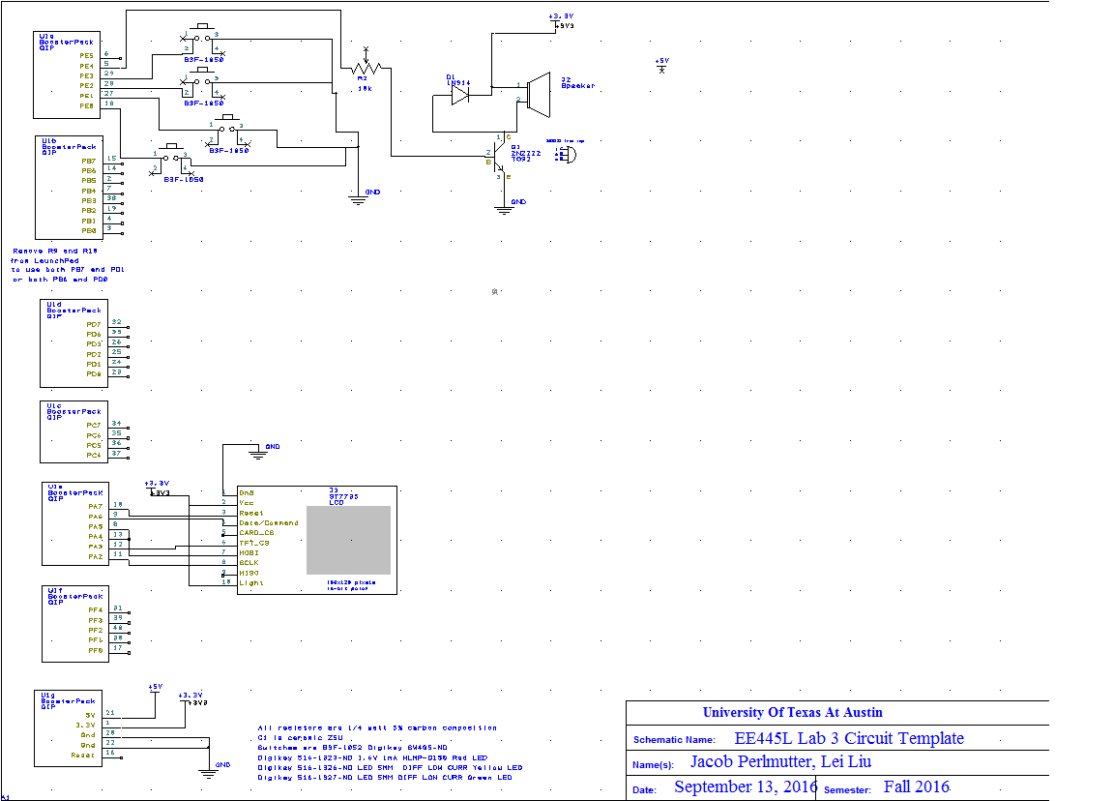

**C) Software Design**

Software Design

All .c and .h files have been created to be used for this project.

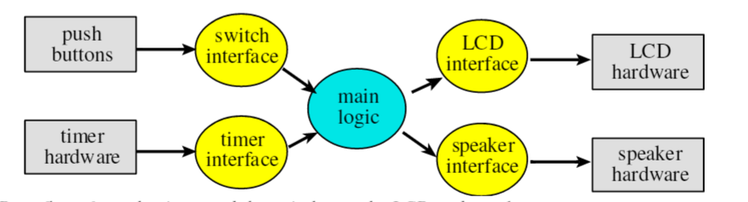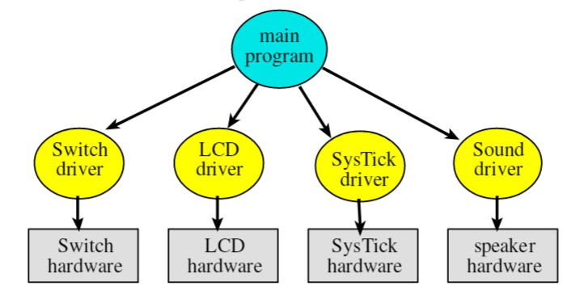

We have decided to go with the second diagram where main will be running and calling the other functions.

**D) Measurement Data**

The DC voltages on the board are stable and in range of operating conditions. The 3.3V voltage supply on the microcontroller is measured to be around 3.36V and the 5.0V voltage supply is measured to be around 5.17V. The voltage ripple on the 3.36V supply is around 160mV as well as the 5.17V supply. The 3.36V supply has a ripple at 113.14 mVrms and the 5.28V has a 113.14 mVrms as well.

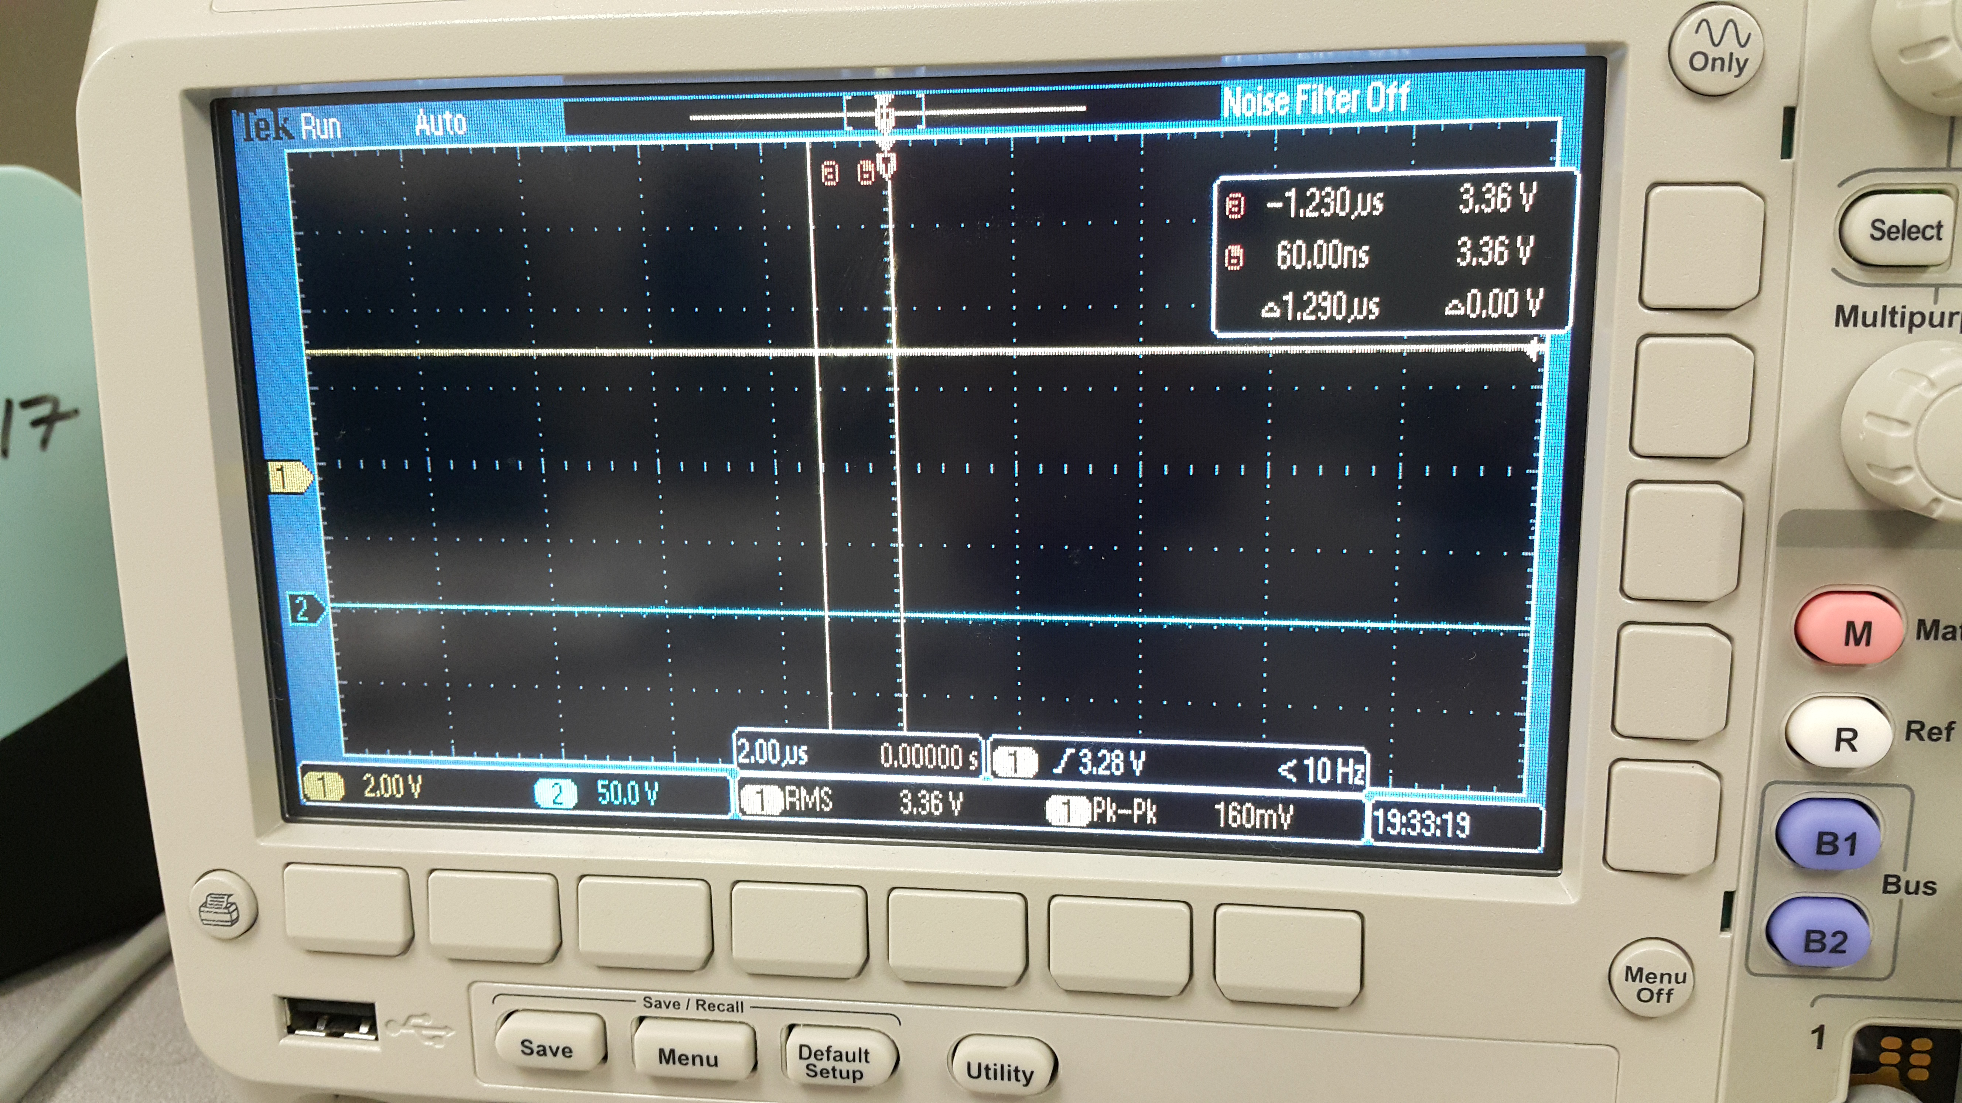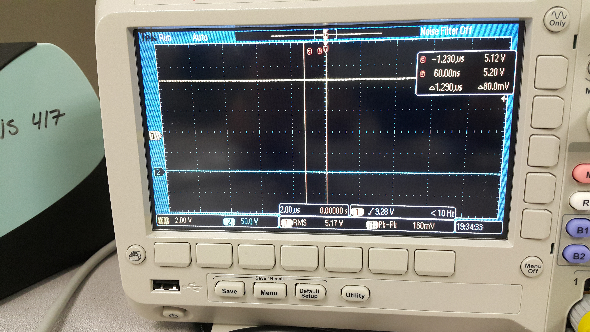

The microcontroller is also run with an external DC voltage supply of 5.0V and the currents required to run the microcontroller were recorded. The current required to run the microcontroller without the speaker going off is about 70 mA and the current required to run the microcontroller with the speaker on is about 101 mA. While the speaker is on, only a little bit more current is needed since the speaker is interfaced with a high resistance resistor.

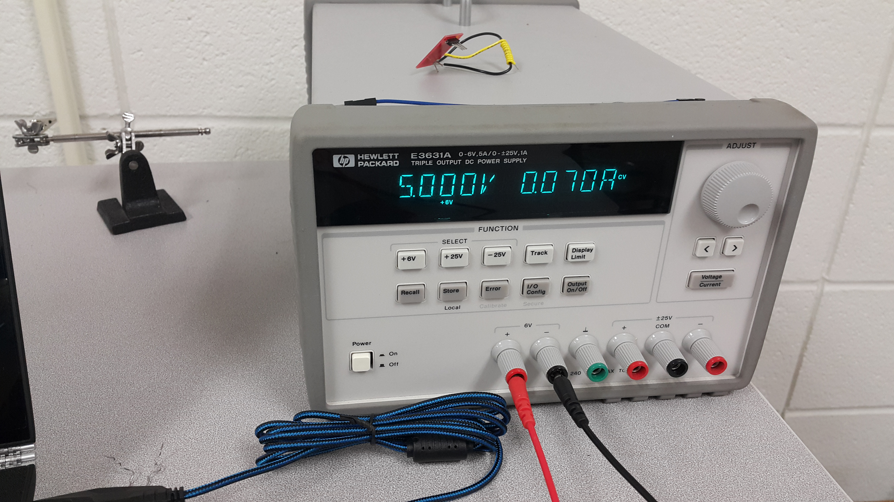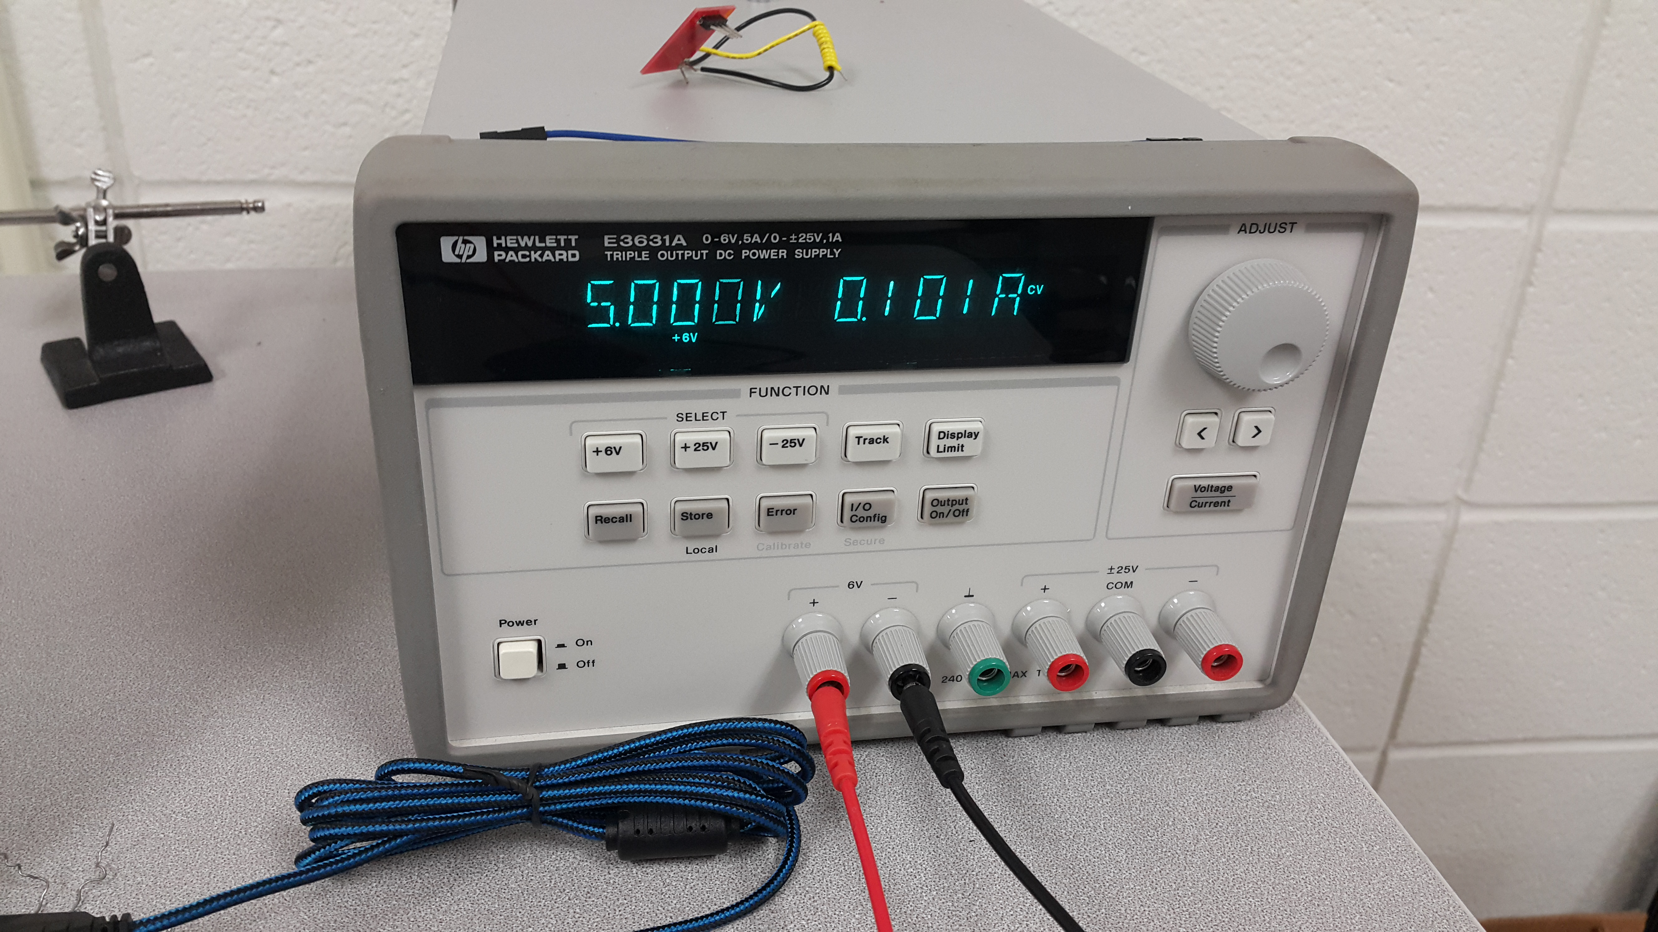

**E) Analysis and Discussion**

1. Two methods to remove critical section is to either remove global variables so critical section cannot change any data in other handler’s stack and another method is to disable interrupts for the duration it is modifying any data.
2. It takes about 15 ms to draw the clock onto the LCD with the new time.
3. Updating the LCD in the background of an interrupt service routine will increase latency in the program and it can cause the system to not be in real time anymore. This can lead to many issues such as a clock being inaccurate in giving time.
4. We outputted the clock frame once and displayed clock hands only when the time was changed.
5. If the system were to run on a battery then a few ways to save power can be reducing clock cycles, updating the LCD less frequently, and setting the alarm off for a shorter duration.